System User Manual

This image retrieval system uses C++ as the development language, Qt5.12 as the main development framework for interface design, OpenCV4.4 as the development tool library, and MySQL database to design and implement the functions of the system.

System development environment: OS Windows 10, CPU i5-4300U, RAM 8G.

Before running the program, you should ensure the *successful installation of MinGW x64 version of Qt (5.12 and above) and Qt Creator (Community), configure OpenCV (4.4 and above) in Qt using CMake, install and debug MySQL database.*

Use Qt Creator to open the project file with the suffix pro in the image_retrieval file, and modify the corresponding hostname, port number, database name, username and password in the mainwindow.cpp file under source (there are two places in total, you can use the shortcut Ctrl+F to find and modify them quickly).

Build and run the project in Qt Creator, verify that the database is successfully connected and then test it with the images in the Gallery and Gallery_Gray files.

Showing a successful connection to the database and correct output shows that the system works properly in the current environment and that the user can use the system to complete image 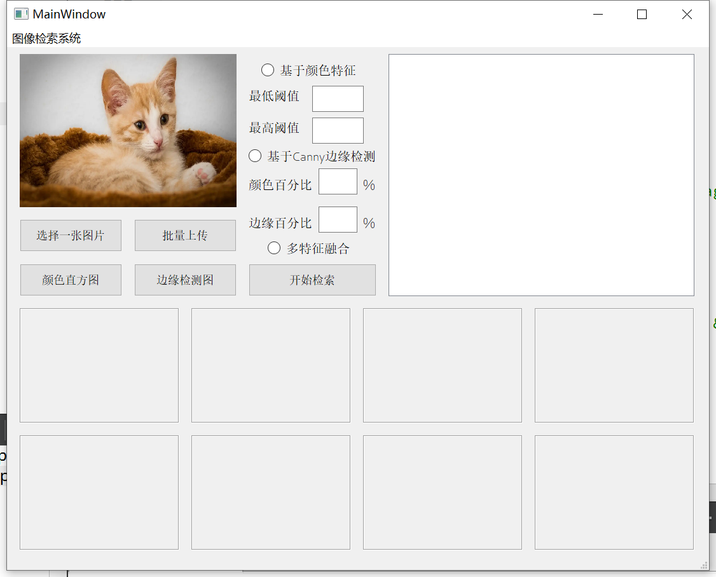related upload and retrieval operations normally.

Image Retrieval System

Canny Edge Detection

Color-feature Based

Edge Detection Map

Bulk Upload

Select an image

Color Histogram

Start Retrieving

Multi-feature Fusion

Percentage of Color

Percentage of Edge Detection

Max-Shreshold

Min-Shreshold

The specific steps are as follows:

1. Click the "Bulk Upload" button to open a folder to select images for bulk upload to the database.

2. Click the "Select an image" button to open the folder and select an image to be retrieved.

3. Click the "Color Histogram" button to view RGB color space information.

4. Click the "Edge Detection Map" button to view the edge detection map, and drag the slider below to display the edge detection map based on Canny operator at the corresponding minimum threshold.

5. Click the "Color feature-based" radio button, click the "Start Retrieving" button to view the color feature-based search results, click the corresponding box at the bottom of the system to view the corresponding HSV color space histogram, in the upper left corner of the histogram In the upper left corner of the histogram and the table in the upper right corner of the system, you can view the similarity values of color features corresponding to different image files.

6. Click the "Canny Edge Detection" radio button and type in the minimum and maximum threshold values (0-250) based on the threshold range determined by the user by dragging and dropping the slider in the edge detection map, or use the default values of minimum threshold 80 and maximum threshold 150, and click the "Start Retrieving "button to search. After waiting for the system to run for a period of time, you can view the retrieval results based on Canny edge features.

7. Click the "Multi-feature Fusion" radio button and type in the desired color percentage value and edge percentage value (>0%) based on the results of the first two steps, or use the default percentage values of 50% and 50%, and click the "Start Retrieving" button to search. The search results based on multi-feature fusion can be viewed by clicking the corresponding box of the retrieved image at the bottom of the system to view the corresponding HSV color space histogram and feature point matching composite result map.

8. You can find the images under the corresponding file paths in the table based on the search results, which completes all the operations of one image search.